**Designing The EditPaperFrame**

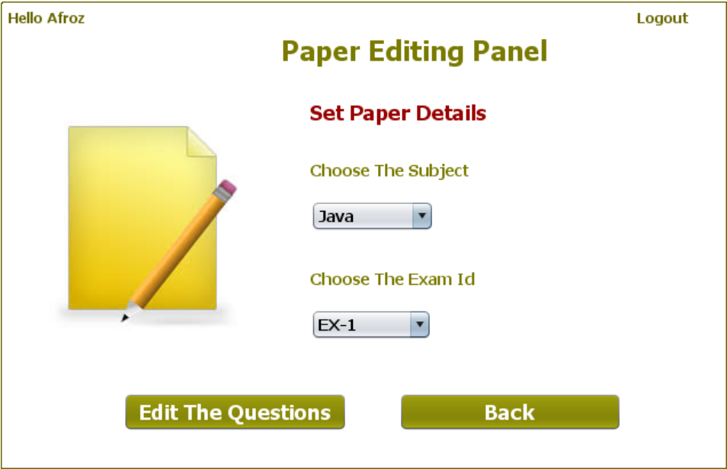

**STEPS TO BE DONE IN** **EditPaperFrame**

In the **EditPaperFrame** we need to do following steps:

1. Display **username** on the top left

2. Allow the user to **logout**

3. Write code for selecting all **Exam Id** of the **selected subject** from the database ***as soon as subject is selected.***

Since subject names are displayed in the **JComboBox** , we need to handle it's **actionPerformed( )** method as it is the event that gets called as soon as the user selects an item in the **JComboBox**. We need to perform following steps in the **actionPerformed( )** method of the **JComboBox**:

**a. Verify whether the user has selected any subject or not. If not it should print the Error Message and return.**

**b.Call the method getExamIdBySubject( ) method of ExamDAO which accepts a subject name as argument and returns the list of Exam-Id of that subject.**

**c. Finally we should display the Exam-Id returned in the second JComboBox**

4. Write code for the "**Edit the Questions**" Button. When this button is clicked it should:

**a. Validate the inputs. If validation fails it should print the Error Message and return**

**b. If validation passes, it should fetch total number of questions of this exam from the database by calling the method getQuestionCountByExam( ) of the ExamDAO class.**

**c. Finally it should create an Exam object, fill the** **Exam** **details** (**Exam Id**,**subject**,**total no of questions**) **and pass this object to the** **EditQuestionsFrame**

**d. Dispose the current frame**

4. Write code for the "**Back**" Button. When this button is clicked it should:

a**. Dispose the current frame and open the AdminOptionsFrame**

**THE TABLES USED IN EditPaperFrame**

**1. EXAM**

|  |  |  |
| --- | --- | --- |
| **Column Name** | **Data Type** | **Description** |
| **EXAMID** | **Varchar2(10)** | **Contains id of the paper** |
| **LANGUAGE** | **Varchar2(10)** | **Contains the programming language name** |
| **TOTAL_QUESTION** | **Number(4)** | **Contains total number of question present** |

**THE POJO CLASSES USED IN EditPaperFrame**

1. The **Exam** POJO

**THE DAO CLASSES USED IN EditPaperFrame**

1. The **ExamDAO**

We will call the method **getExamIdBySubject( )** of **ExamDAO** to get all Exam-Id of the subject name passed as argument from the **EXAM** table.

The protoype of the method is:

***public static ArrayList<String> getExamIdBySubject(String subject)throws SQLException***

Now we have to create the **getQuestionCountByExam( )** method in the **ExamDAO** to get the total number of questions of a particular exam from the **EXAM** table.

The prototype of the method is:

***public static int getQuestionCountByExam(String examId)throws SQLException***